**Program sample output:**

**% java quakes –top5**

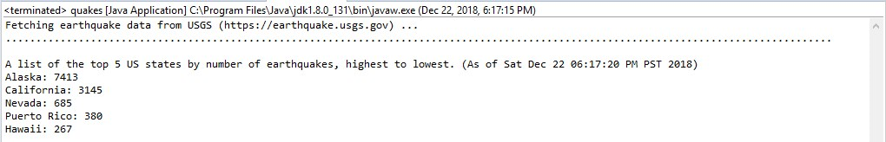

**% java quakes --NH**

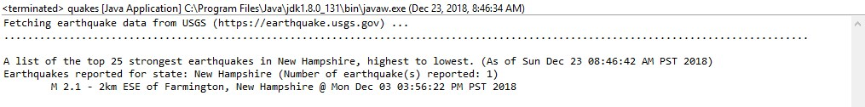

**% java quakes --nh**

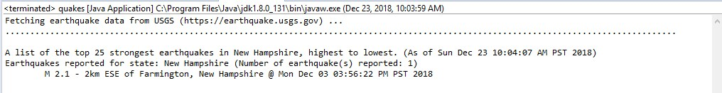

**% java quakes –WV**

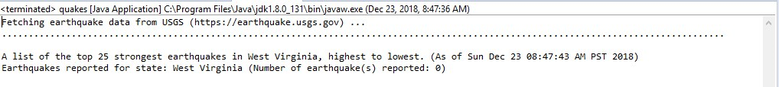

**% java quakes –wv**

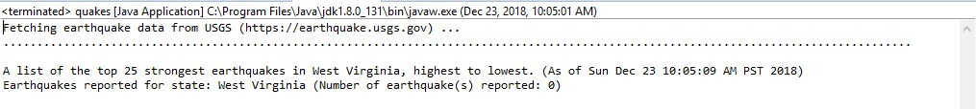

**% java quakes --NC**

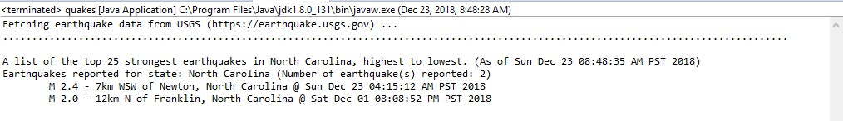**% java quakes –nc**

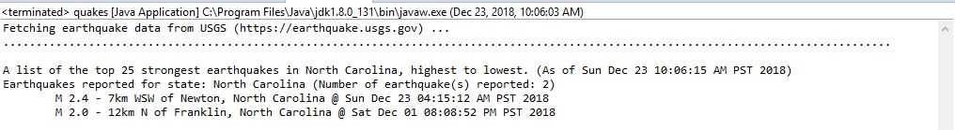

**% java quakes --California**

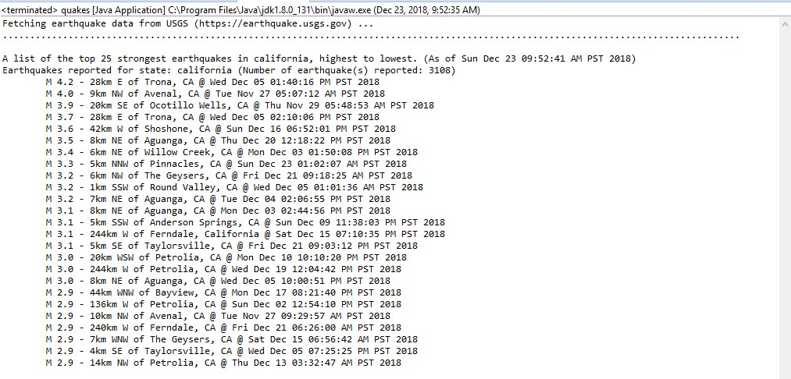

**% java quakes –california**

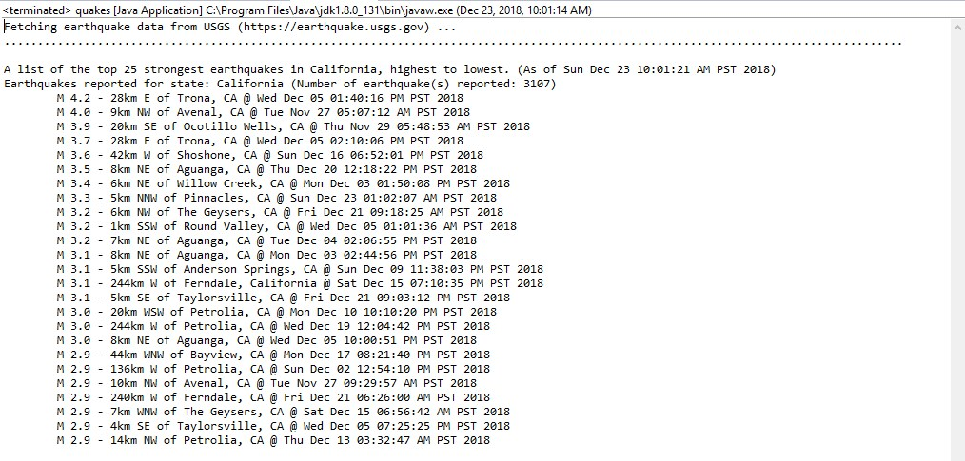

**% java quakes –CA**

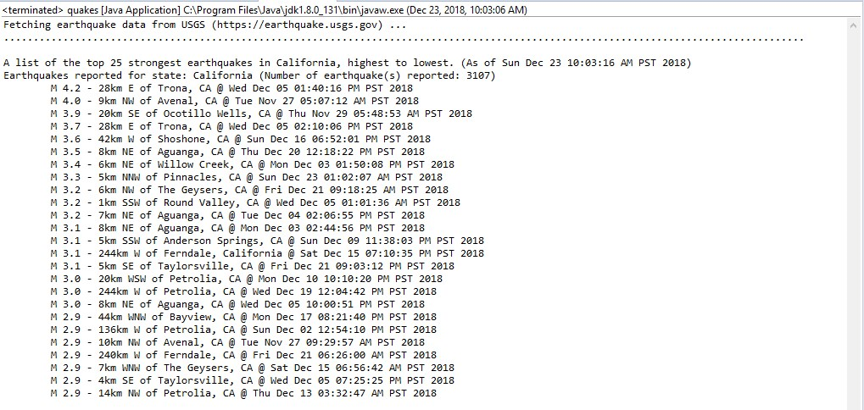

**% java quakes –ca**

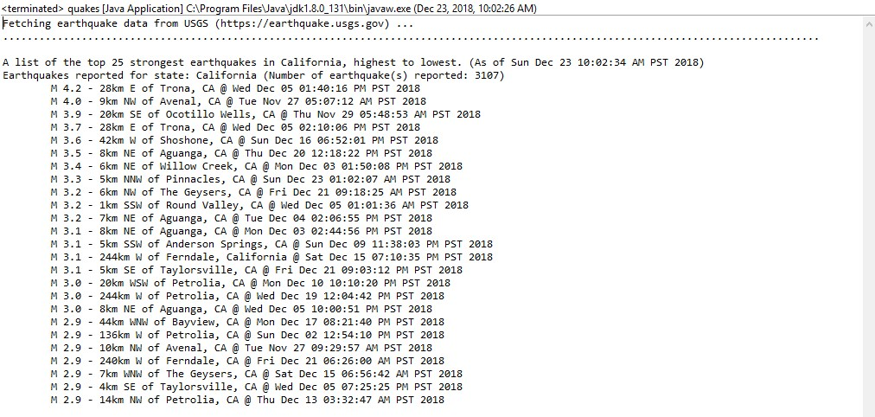

**% java quakes –Alaska**

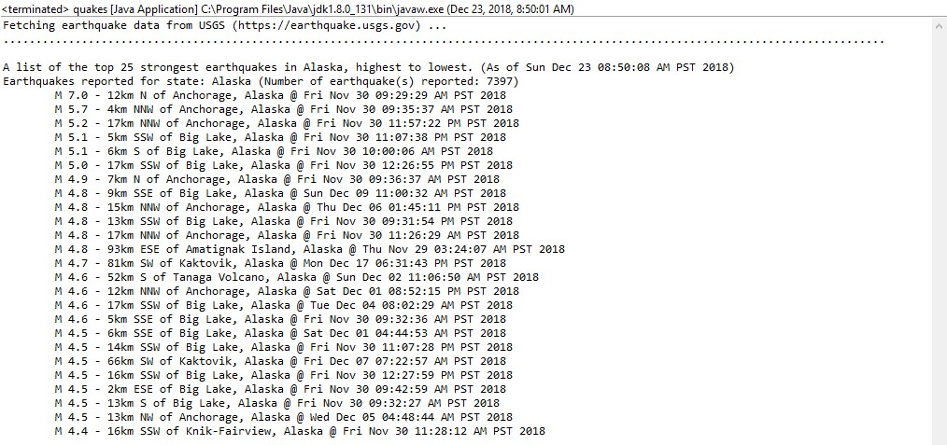

**% java quakes –gu**

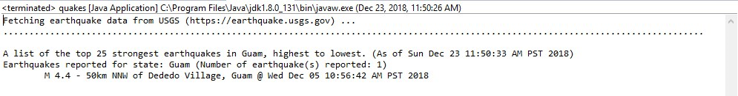

**% java quakes –guam**

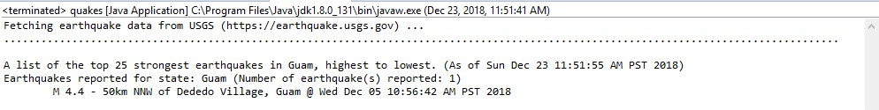

**% java quakes –vi**

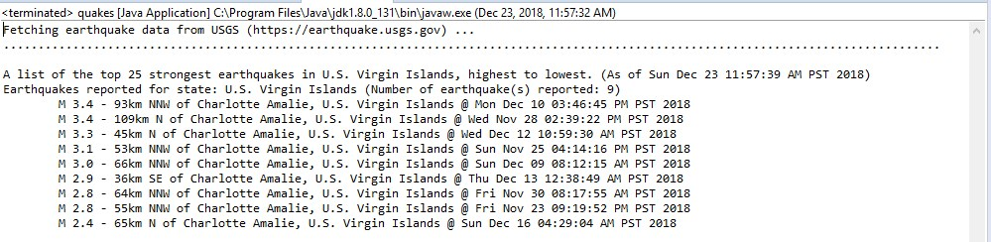

**% java quakes –statestop5**

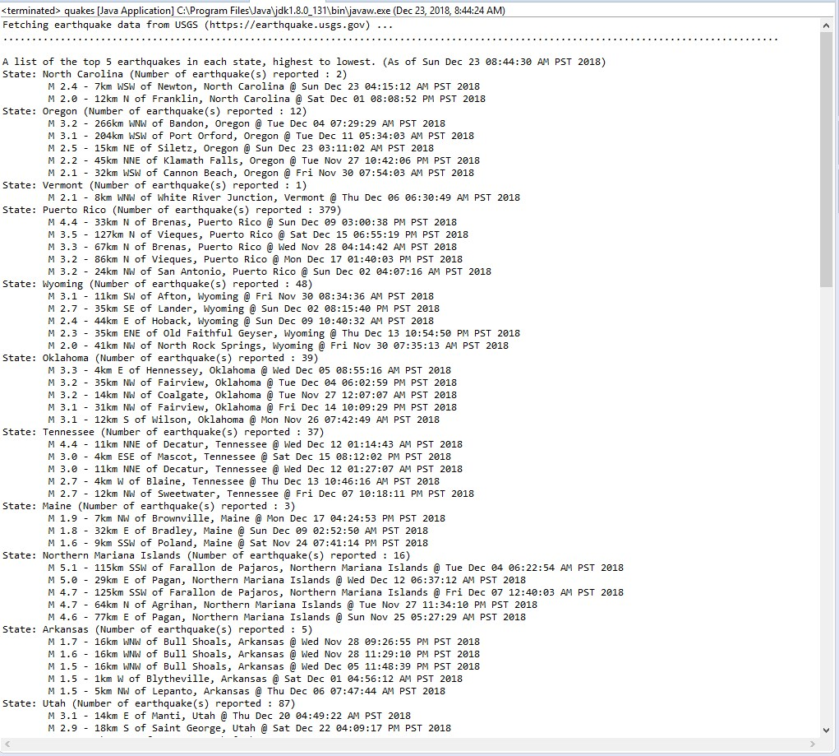

**% java quakes**

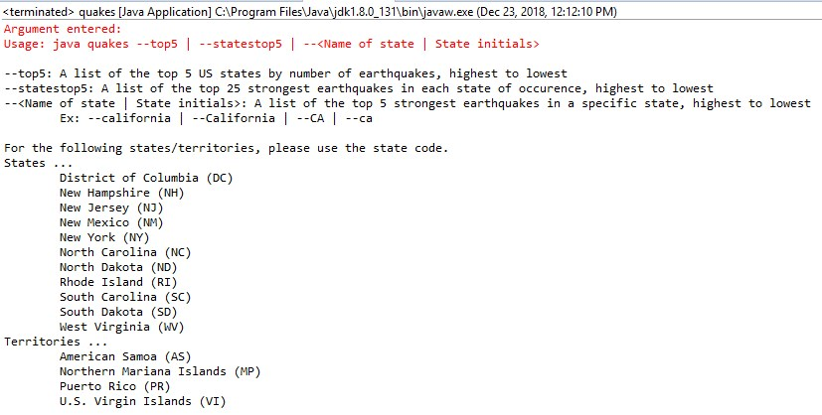

**% java quakes –**

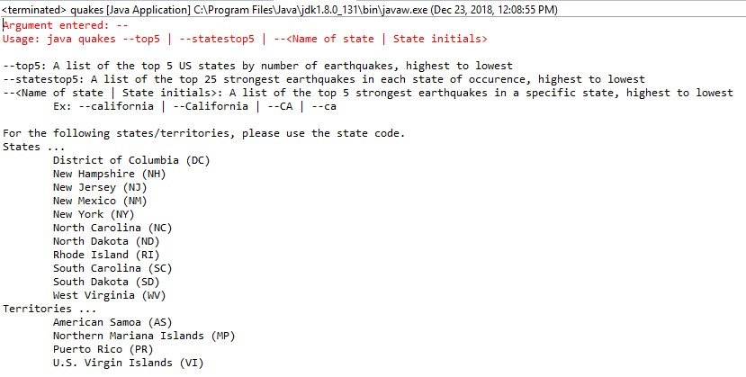

**% java quakes –top**

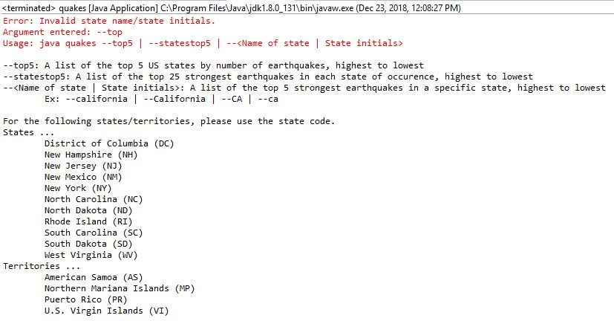

**% java quakes –Alask**

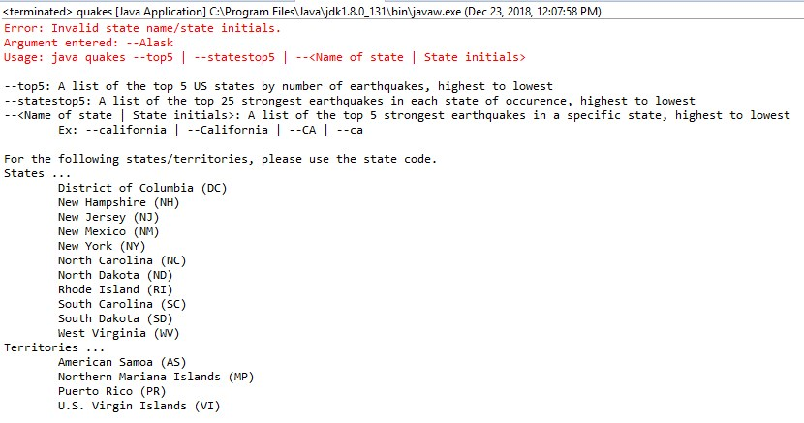

**% java quakes –nz**

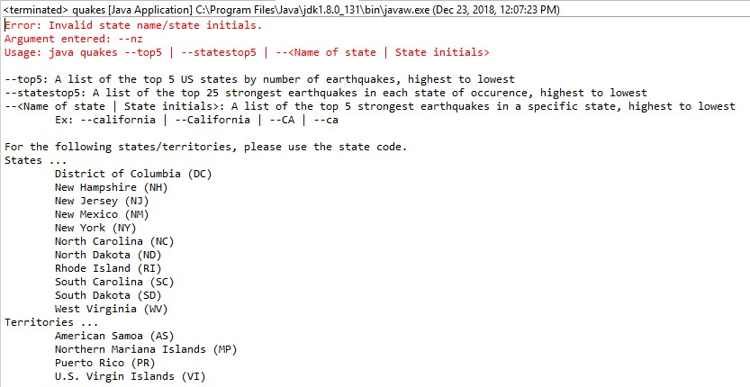

**% java quakes –-top5 --ca**

